**2. MLR (Multi Linear Regression Analysis)**

**For the execution of cell run shift + enter**

[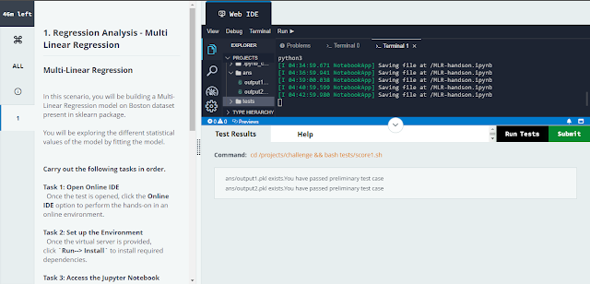](https://1.bp.blogspot.com/-aA4Ow1wbC3s/YLH6ZcQIsqI/AAAAAAAAITg/p-sp2fXlbFgUpvmlZG592hwCtYyILXmUwCLcBGAsYHQ/s1366/MLR.PNG)

**cell 1:-**

**from sklearn.datasets import load_boston**

**import pandas as pd**

**boston = load_boston()**

**dataset = pd.DataFrame(data=boston.data, columns=boston.feature_names)**

**dataset['target'] = boston.target**

**print(dataset.head())**

**cell 2:-**

**X = dataset.drop('target',axis=1)**

**Y = dataset['target']**

**cell 3:-**

**print(X.corr())**

**corr_value = 0.29**

**cell 4:-**

**import statsmodels.api as sm**

**X = sm.add_constant(X)**

**fitted_model = sm.OLS(Y,X).fit()**

**print(fitted_model.summary())**

[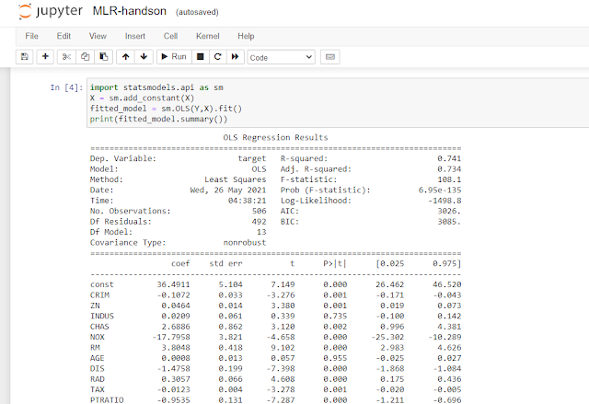](https://1.bp.blogspot.com/-LPiioVIenmw/YLH64Gy4mFI/AAAAAAAAITs/xdIVgSJ1qu4VeY97u29v5BRr1m03ks0rACLcBGAsYHQ/s953/MLR%2BJUPYITOR%2BCODE.PNG)

**cell 5:-**

**r_squared = 0.96**

**cell 6:-**

**import hashlib**

**import pickle**

**def gethex(ovalue):**

**hexresult=hashlib.md5(str(ovalue).encode())**

**return hexresult.hexdigest()**

**def pickle_ans1(value):**

**hexresult=gethex(value)**

**with open('ans/output1.pkl', 'wb') as file:**

**hexresult=gethex(value)**

**print(hexresult)**

**pickle.dump(hexresult,file)**

**def pickle_ans2(value):**

**hexresult=gethex(value)**

**with open('ans/output2.pkl', 'wb') as file:**

**hexresult=gethex(value)**

**print(hexresult)**

**pickle.dump(hexresult,file)**

**pickle_ans1(corr_value)**

**pickle_ans2(r_squared)**